SKILLS HUB
Software Requirements Specification

Version 1.0



Group Id:
Supervisor Name: Musaddiq Hussain

Revision History
Date (dd/mm/yyyy) | Version | Description | Author
5/12/2023 | 1.0 |  | xxxx  Rubina Batool

Table of Contents

- Scope (of the project)
- Functional Requirements Non Functional requirements
- Use Case Diagram
- Usage Scenarios
- Adopted Methodology
- Work Plan (Use MS Project to create Schedule/Work Plan)

SRS Document

Scope of Project:
xxxxxxxxxxxxxxxxxxxxxxxxxxxxxxxxxxxxxxxx

Functional and non Functional Requirements:

FUNCTIONAL REQUIRMENTS: -
There are mainly three stakeholders/actors of this project those are Admin and Workers and users each actor has its own different functional requirements we will discuss all these functionalities one by one.
USER PANEL
User can create an account and provide personal information.
User can update and manage their profile.
User can search and select a specific skilled worker.
User can view profiles and ratings of available skilled workers.
WORKER PANEL
Skilled workers can register and create profiles, providing details such as their skills, certifications, work history, and availability.
ADMIN PANEL
Admin has access to a dashboard for managing service requests and skilled workers.
Admin can add, edit, and activate/deactivate skilled worker profiles.

NON-FUNCTIONAL REQUIREMENTS
Usability:
Usability of the software can be easy so that the user can use it easily without any difficulty
Maintainability:
Software should be built up in such a way that classification of errors and maintains of application becomes easy
Operating System:
Software should be able to run on all type of operating systems like Windows XP, Window 7 and others.
Some of the others are:
Accessibility
Security
Actors:
The system consists of two main modules as follows:
Admin
Users
Skilled Worker
Tools: PHP, MySQL, VsCode, Google Chrome , Notepad++ etc.
Application Type: Web based Application

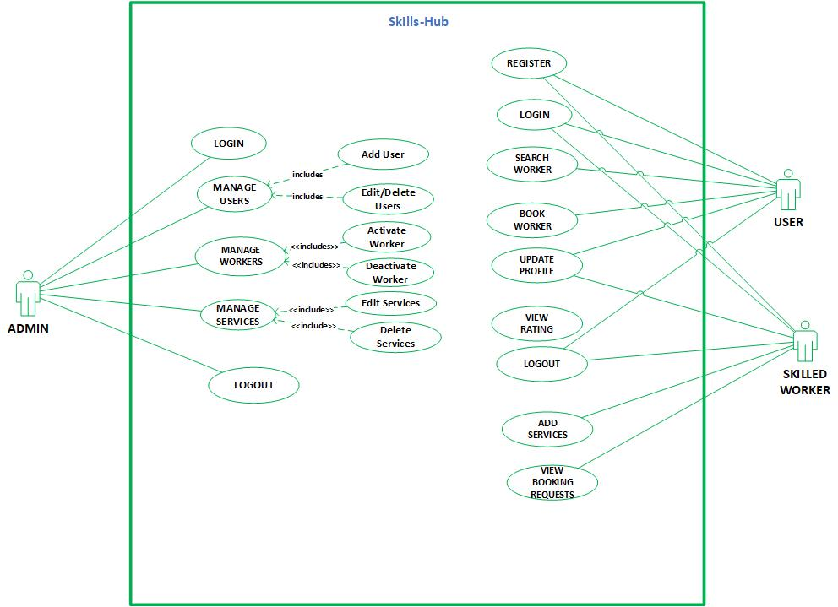
Use Case Diagram(s):

USAGE SCENARIOS:
REGISTER:

Use Case id | 1
Use Case title | REGISTER
Description | All Users/Skilled Worker who wants to use this system must have to register themselves on this website.
Pre-condition | Application interface must be available.
Action | - Open application interface of create account  - Fill the form of registration  - Click on “Register” button to get registered
Post Conditions | Users/Skilled Worker successfully created in database.
Alternative Path: | Users/Skilled Worker may not want to register this time
Exception: | If the user entered invalid data in the form then the exception occurs “Fill mandatory Fields”
Authority | Users/Skilled Worker
Author

LOGIN:

Use Case id | 2
Use Case title | LOGIN
Description | All stakeholders/Actors of the website must have to login to use some key features of this website.
Pre-condition | Actors must be registered with our website , Application interface must be available
Action | - Open application interface of login  - Enter user name and password  - Click on “Login” button
Post Conditions | Actors successfully login and able to further work
Alternative Path: | Actors may not want to login this time
Exception: | If the user entered invalid data in the form then the exception occurs “Invalid user name and password”
Authority | Users/Skilled Worker, Admin
Author

SEARCH WORKER:

Use Case id | 3
Use Case title | SEARCH WORKER
Description | This use case allows Users to search the desired Worker available on our system
Pre-condition | Application interface must be available
Action | - Open application interface and fill the criteria of search job.  - Click on the “SEARCH” button
Post Conditions | All workers who fall on the search criteria will be displayed on the website
Alternative Path: | Users may not want to search job this time
Exception: | If none of the worker who matches search is not available in the database no item will be displayed.
Authority | Users
Author

UPDATE PROFILE:

Use Case id | 4
Use Case title | UPDATE PROFILE
Description | This use case allows users and skilled worker of the system to update their profile which is later on available on our website.
Pre-condition | User of the system must be registered with our website and logged in.
Action | - Login as Users/Skilled Worker  - Fill update profile form  - Click on “Update Profile” button
Post Conditions | Profile successfully updated and
Alternative Path: | -
Exception: | If the user entered invalid data in the form then the exception occurs “Please enter correct and valid data”
Authority | Users, Skilled Worker
Author

ADD RATING:

Use Case id | 11
Use Case title | ADD RATING:
Description | This use case is about adding/giving rating to Skilled Worker
Pre-condition | Application interface must be available. And system must be logged in as user
Action | - Open application interface and select particular skilled worker  - Give Rating Through Star rating  - Submit your Rating
Post Conditions | Rating submitted and send to that particular Skilled Worker
Alternative Path: | -
Exception: | -
Authority | Skilled Worker
Author

ADD SERVICES:

Use Case id | 4
Use Case title | ADD SERVICES
Description | This use case allows skilled workers of the system to add services which they provide later on these services make available on our website for users.
Pre-condition | Skilled Worker of the system must be registered with our website and logged in.
Action | - Login as Skilled Worker  - Fill add services form  - Click on “Add Services” button
Post Conditions | Services successfully added and available on our website for users.
Alternative Path: | -
Exception: | If the user entered invalid data in the form then the exception occurs “Please enter correct and valid data”
Authority | Skilled Worker
Author

MANAGE USERS:

Use Case id | 6
Use Case title | MANAGE USERS
Description | This usecase allows admin user of the system to manage all skakeholders i.e Users , Skilled Workers registered on website any time
Pre-condition | Application interface must be available. And system must be logged in as Admin
Action | - Open application interface of create account  - View manage_user.php page  - Select Particular user to manage  - Perform your desired actions i.e eidt/delete
Post Conditions | Upated information added in database.
Alternative Path: | Admin may not want to manage user this
Exception: | If the user entered invalid data in the form then the exception occurs “Fill mandatory Fields”
Authority | Admin
Author

MANAGE SERVICES:

Use Case id | 8
Use Case title | MANAGE SERVICES
Description | This usecase allows admin user of the system to manage all services added by Skilled Workers.
Pre-condition | Application interface must be available. And system must be logged in as Skilled Worker
Action | - Open application interface of create account  - View manage_services.php page  - Select Particular Service to manage  - Perform your desired actions
Post Conditions | Upated information added in database.
Alternative Path: | Admin may not want to manage job this time
Exception: | If invalid data entered in the form then the exception occurs “Fill mandatory Fields”
Authority | Admin
Author

LOGOUT

Use Case id | 12
Use Case title | LOGOUT
Description | This use case allows all the actors of the system to logout from website.
Pre-condition | The application interface must be available and any of the actor must be Logged in.
Action | - Open application interface.  - Click on Logout Button.
Post Conditions | Session is destroyed and actor will be logout from system.
Alternative Path: | Force close website.
Exception: | If session is empty than this feature is not available.
Authority | Admin, Skilled Worker , Users
Author

Adopted Methodology
Development of any software product or application choice of right model is very important. The selection of model has very high impact on the testing that is carried out. It will define that what, where and when of our planned testing, influence regression testing and which test techniques to use. The development models are the various processes or methodologies that are being selected for the development of the project depending on the project aims and goals. There are many development life cycle models that have been developed in order to achieve different required objectives. The models specify the various stages of the process and the order in which they are carried out There are various Software development models or methodologies we discus Water Fall and Spiral Model in the following.

Waterfall Model:
The waterfall Model is a linear sequential flow. In which progress is seen as flowing steadily downwards (like a waterfall) through the phases of software implementation. This means that any phase in the development process begins only if the previous phase is complete. The waterfall approach does not define the process to go back to the previous phase to handle changes in requirement. The waterfall approach is the earliest approach that was used for software development.
Diagram
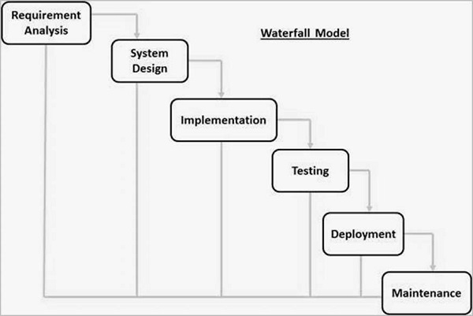
Spiral Model:
The spiral model is similar to the incremental model, with more emphasis placed on risk analysis. The spiral model has four phases: Planning, Risk Analysis, Engineering and Evaluation. A software project repeatedly passes through these phases in iterations (called Spirals in this model). The baseline spiral, starting in the planning phase, requirements are gathered and risk is assessed. Each subsequent spirals builds on the baseline spiral.
Planning Phase:
Requirements are gathered during the planning phase.
Risk Analysis:
A prototype is produced at the end of the risk analysis phase. If any risk is found during the risk analysis, then alternate solutions are suggested and implemented.
Engineering Phase:
In this phase software is developed, along with testing at the end of the phase. In this phase the development and testing is done.
Evaluation phase:
This phase allows the customer to evaluate the output of the project to date before the project continues to the next spiral.
Diagram of Spiral model:
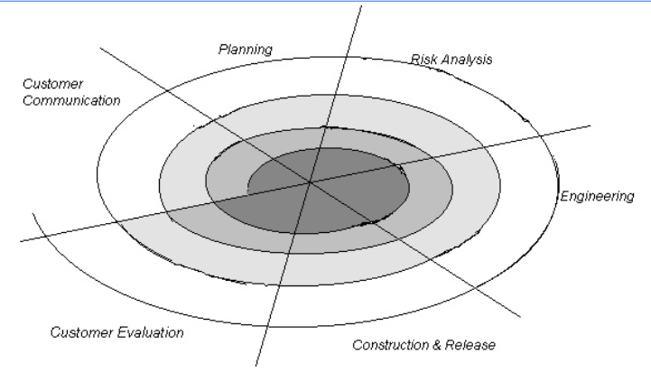
VU Process Model:
The methodology chosen for this project is VU Process Model. The vu process model, offers numerous advantages for software developers and because of its beneficial flow I use this methodology. This model is a combination of Waterfall and Coiled/Spiral Model. This is a hybrid approach of system development, which maximizes the quality of system and minimizes the disadvantages and risks.
VU process model has four phases; each phase is tested on its completion. It
conserves resources and is superlative for sustaining less skilled plan teams and project managers whose composition fluctuates. The errors are removed due to iteration to previous or next phases. The orderly sequence of development steps and strict controls for ensuring the adequacy of documentation and design reviews helps ensure the quality, reliability, and maintainability of the developed software. The progress of system development is measurable.VU Process model depicts the linear nature of waterfall and iterative risk analysis of spiral. We analyze each phase activity with the end product. VU Process model will help us in identification of risk at the time as it omits. So resolution of that risk will be much easy at that point, while if it is detected at later stage then the resolution will become much more painful and costly (time& budget). Also documentation makes the maintenance of product after its delivery easy. So by combining the spiral & waterfall we get the benefits of waterfall and risk sensitivity of the spiral.
REASONS FOR CHOOSING THE METHODOLOGY
- The Waterfall Model is a documentation-driven model. It therefore generates complete and comprehensive documentation and hence makes the maintenance task much easier. Documentation helps to keep track to risk.

- It suggests a systematic, sequential approach to software development that begins at the system level and progresses through the analysis, design, coding, testing, and maintenance.
Vu Process Model Diagram;
Analyzing & Gathering requirement

Planning Phase

Analysis & Design Phase

Development Phase

Operation & Maintenance
Analysis and Design Phase
Development Phase
Operation & Maintenance

Work Plan (Use MS Project to create Schedule/Work Plan)

SRS AND DESIGN DOCUMENT
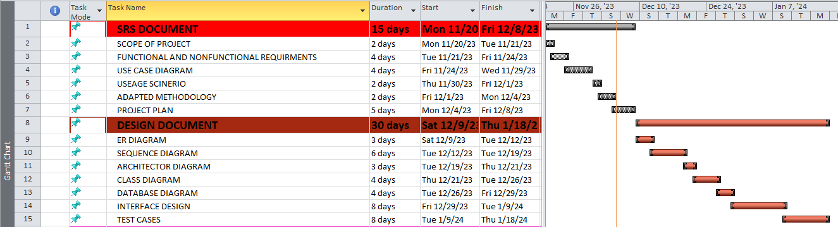

TESTPHASE AND FINAL DELIVERABLES

